Screenshot of your IAM dashboard showing “MFA on root user: Enabled”:
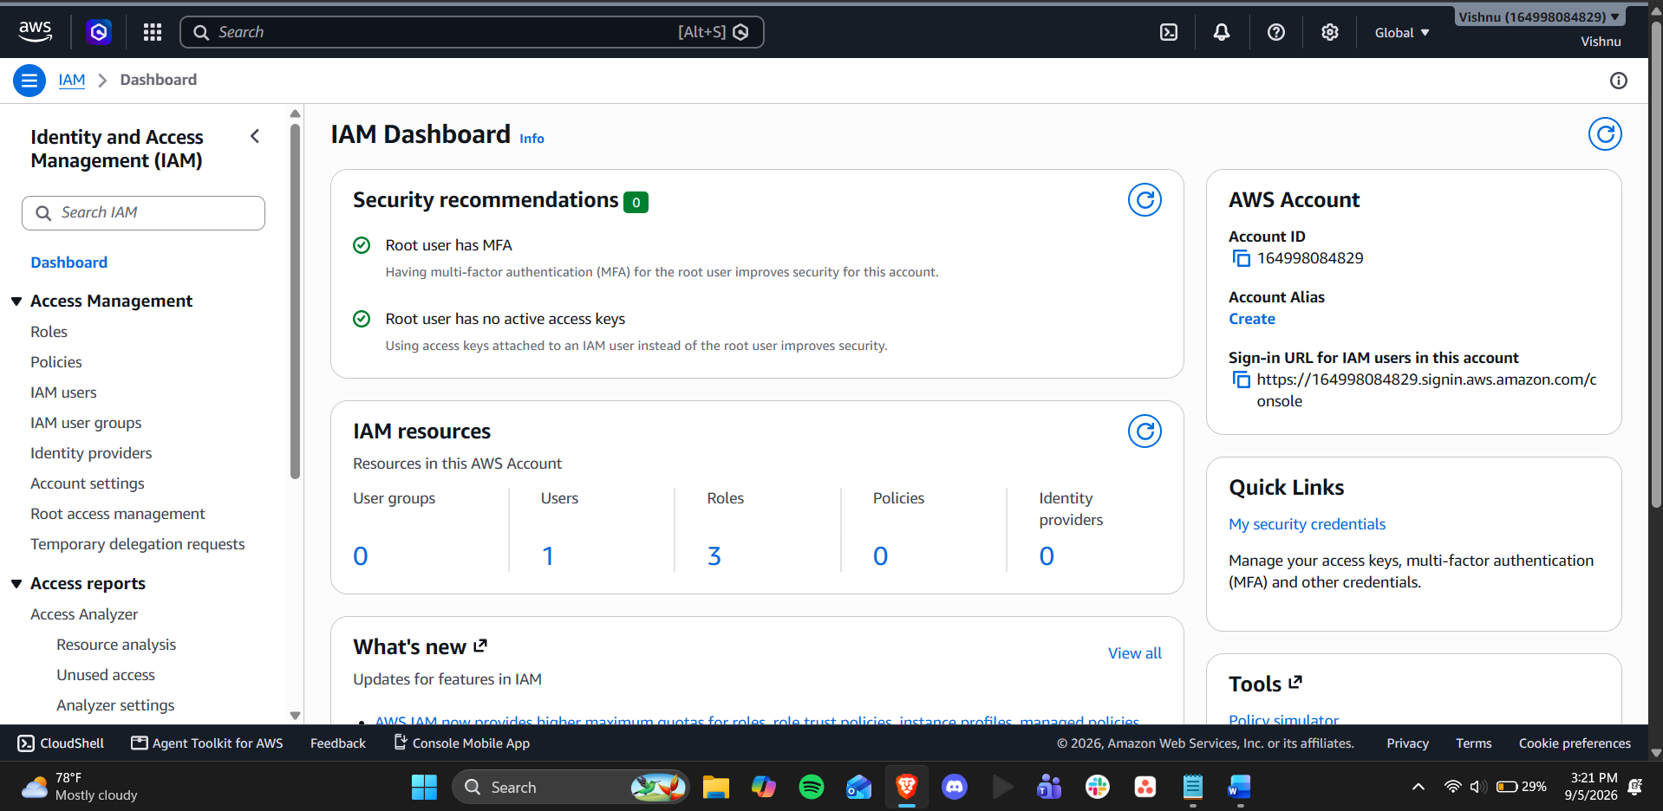

Screenshot of IAM Users list showing lab user:
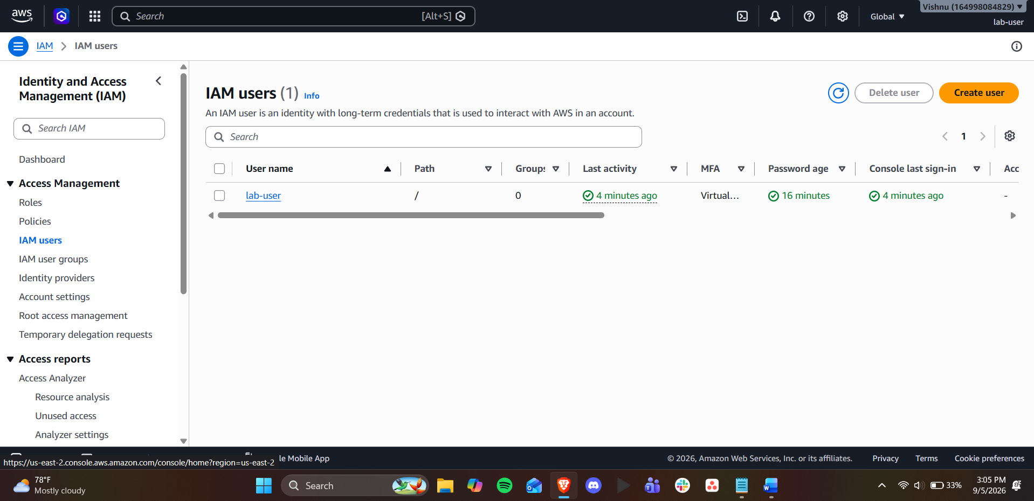

Screenshot showing MFA enabled on the IAM user:
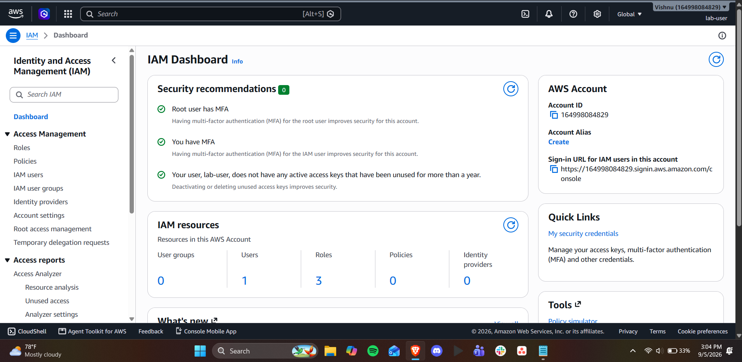

Confirmation that you successfully generated an access key:
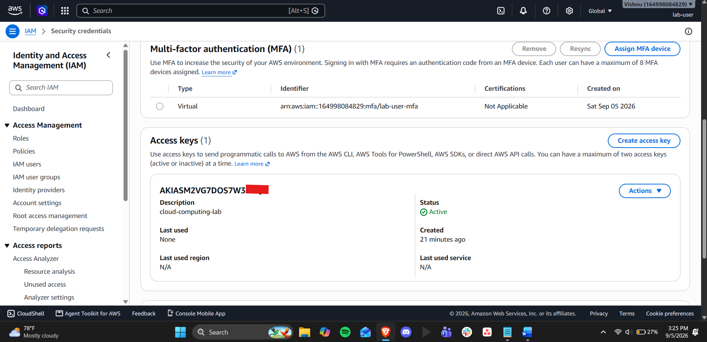

One paragraph reflecting on why root user MFA and least-privilege IAM users matter for cloud security:
sRoot user MFA and Least Privilege IAM is important because if the root account is compromised, the attacker would have full access with no second factor to prevent them from deleting resources, closing an account, or making charges. Without MFA, the root account should be treated as a mandatory account capability, rather than an optional security measure. Least-privilege IAM assumes that a break-in will occur, and grants access to just the resources that a particular role needs rather than all the resources. These practices coalesce around the concept that resilient systems are not merely built to withstand threats and survive when they occur, but they are also designed to minimize their impact and contain them when they happen.

